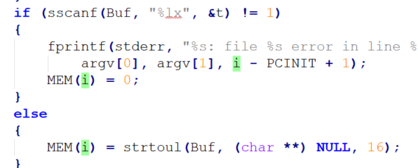



* whatever goes into MEM() gets assigned to Mem[addr / 4].

So first, I is assigned 4000. 4000/4 = 1000.

So, initially, Mem(i) = strtoul() means that Mem[1000] = strtoul(Buf…)

strtoul assigns a string from the file into a hex value. So Mem[1000] = some hex value.



for loop inside of spimcore.c, adds by 4 each iteration, in the for loop in Main.

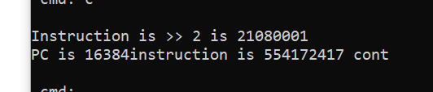

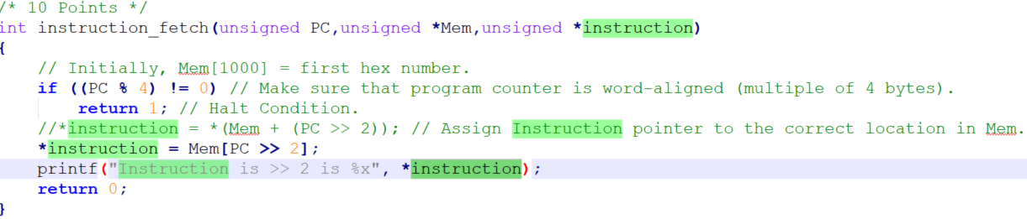



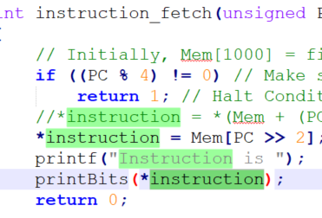

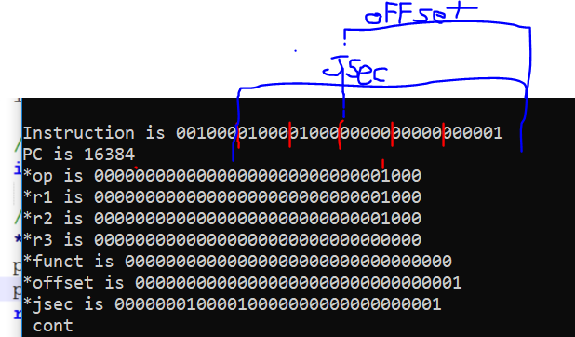

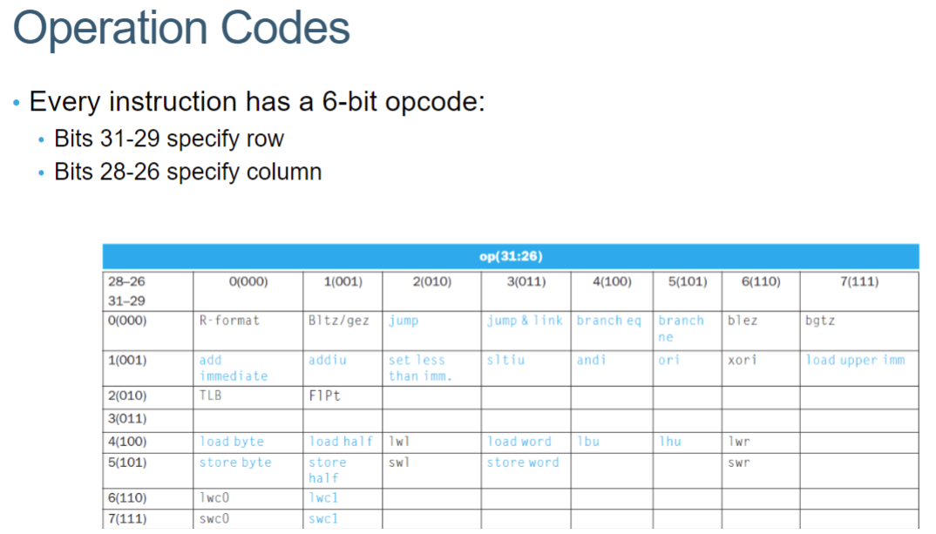

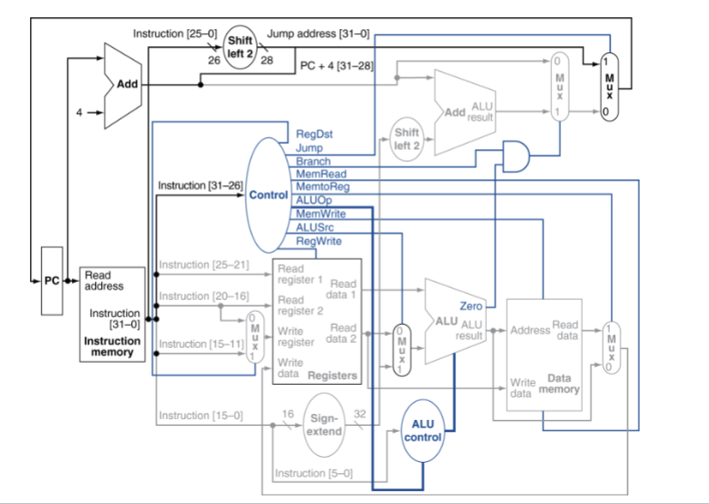

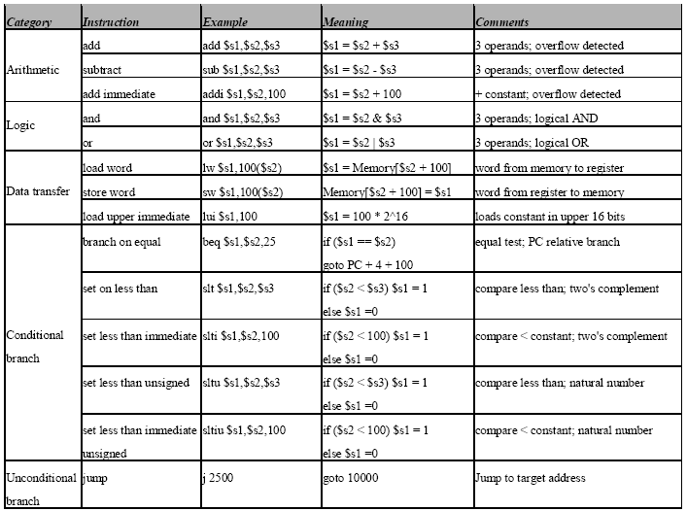  
<http://alumni.cs.ucr.edu/~vladimir/cs161/mips.html>

Great OPCode list.

Opcodes:

add: 0. done

subtract: 0. done

and: 0. done

or: 0. done

jump: 000010: 2. done

beq (000100) = 4. done.

addi: 8. done

slti: 001010: 10. done

sltiu: 001011: 11. done

lui (Load upper immediate): 001111 = 15. done.

lw: 100011 35. done.

sltu: 101001: 41 (Come back to this. many contradictions!). done.

slt: (101010) = 42. done.

sw: 43 (101011). done.

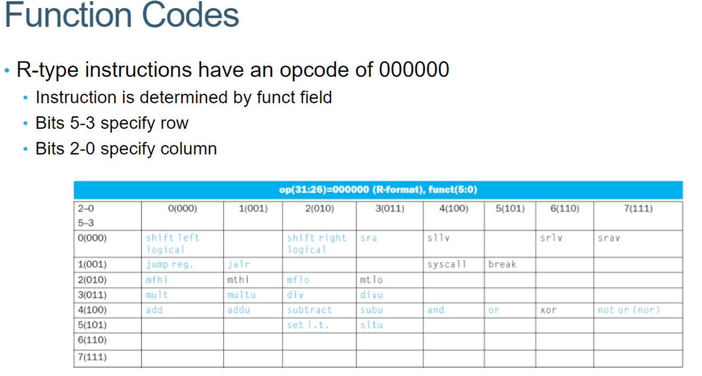

all the blues (functions):

shift left logical 000000 (0) - no factor

shift right logical 000010 (2) - no factor

sra 000011 (3)

jump reg 001000 (8)

jal(r?) 001001 (9)

mfhi 010000 (16)

mflo 010010 (18)

mult 011000 (24)

multu 011001 (25)

div 011010 (26)

divu 011011 (27)

add 100000 (32)

subtract 100010 (34)

and 100100 (36) - DO

or 100101 (37) - DO

set less than 101010 (42) - DO

sltu 101011 (43) - DO

__

Lui:

ALU calculates address to load data from, so needs to take in two values:

* first value will be read_reg1
* 2nd value will be upper_immediate of 16 bit, so take off the bottom 8 bits?

Then, the result gets passed to rw_memory which sets *memdata = Mem[ALUresult >> 2];

Then *memdata gets passed into write_register

So question is how do I know when to set extended_value to upper half?

Answer: need to take the offset and shift it left by 16 bits. But still where is the signal?